19 January 2007 The Weekly Bulletin of Rotary Club of Kathmandu Mid-Town Bc # 29 of 2006-07
Rotary Club of Kathmandu Mid-Town
Breakfast Chatter




District : 3290 Web: www.rotarymidtown.org.np Club Id : 26776

JANUARY IS ROTARY AWARENESS MONTH
Rotary is a group of leaders with a superb network. It is time for us to let the world know about all the good things that we have accomplished over so many years. Through Service Above Self we can all create awareness both internally and externally, thus showing the world the great leadership of Rotary.

Presentations by GSE Team from Brazil at the Club meeting on 12 Jan 2007
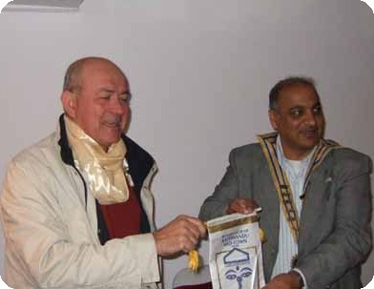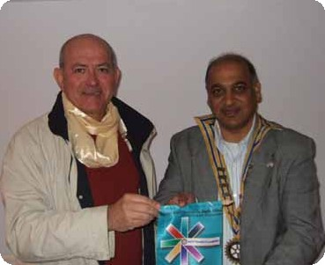
Exchanges of Club banner between Club President and GSE Team Leader
GSE Team from Brazil at the Club meeting:
a) Manoel Lisboa Barbosa, Aracaju, Sergipe - Team leader
b) Saumineo da Silva Nascimento, Suissa, Aracaju
c) Maria Brandao Lopes, Penedo, Alagoas
d) Igor Dias da Silva, Juazeiro, Bahia
e) Luiz Marcos de Oliveira Silva, Aracaju, Sergipe

Weekly Meetings and Programs :
Date | Program/Speaker | Program/Topics of Presentation
19 Jan 2007 | Ranjit Acharya | Personality development basics
26 Jan 2007 | Amanda Rader | RI World Peace Fellowship: One scholar's story
2 Feb 2007 | Dr Narayan Manandhar | Corruption and development

Friday, 19 January :
Mr Ranjit Acharya, Chief Executive Officer of Prisma Advertising, a most aggressive growing advertising agency of Nepal, will be talking on personality development basics. Besides his regular job in his company, Mr Acharya has been taking classes on topics such as personality development, time management, creative thinking process, corporate image building etc in different training programs. While talking on personality development basics he will also be talking on negotiation skills and relationship maintenance.

GSE Team from Brazil at the Club meeting on 12 Jan 2007
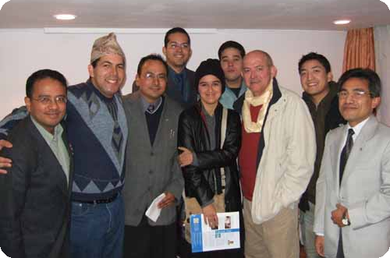
GSE Team members posed for a photo with Club members and Rotaract

On Lighter Side : Click at the figure ⇩


Every project we carry out – every playground we refurbish, every well we help dig, every adult we teach to read, every child we immunize against polio – makes the world we all live in a bit better, a bit healthier, a bit happier.
RI President William B. Boyd

19 January 2007 The Weekly Bulletin of Rotary Club of Kathmandu Mid-Town Bc # 29 of 2006-07

Editor: RR Shrestha, Club Service Director email: rryes@wlink.com.np

